FINAL PROJECT - REPORT 3

PROJECT NAME : Rocket Man and the Knights of Incompetence

PROJECT MEMBERS : Kevin Visser-Weckworth & Phillip Trudeau-Tavara

Program Outline:

Rocket Man and the Knights of Incompetence is a side-scrolling platforming game. The game takes the player on a journey as our hero, Rocket Man, to defeat the bumbling Knights of Incompetence who have occupied his home. The player will fight through multiple levels filled with enemy Knights, and a final level with a larger and stronger boss knight.

Program Screenshots:
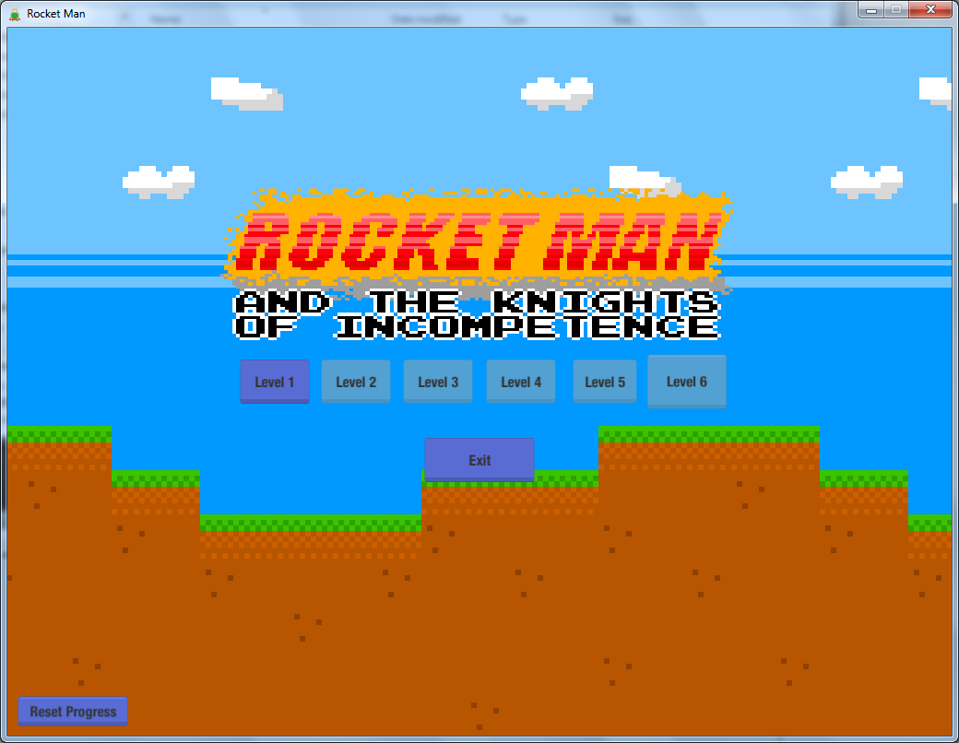
Fig 1: The main menu screen, with level selection
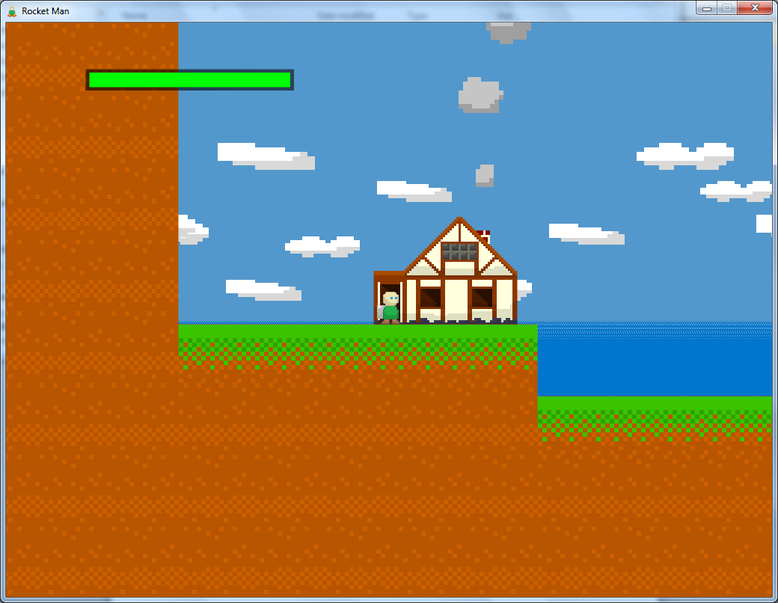
Fig 2: The start of the first level.

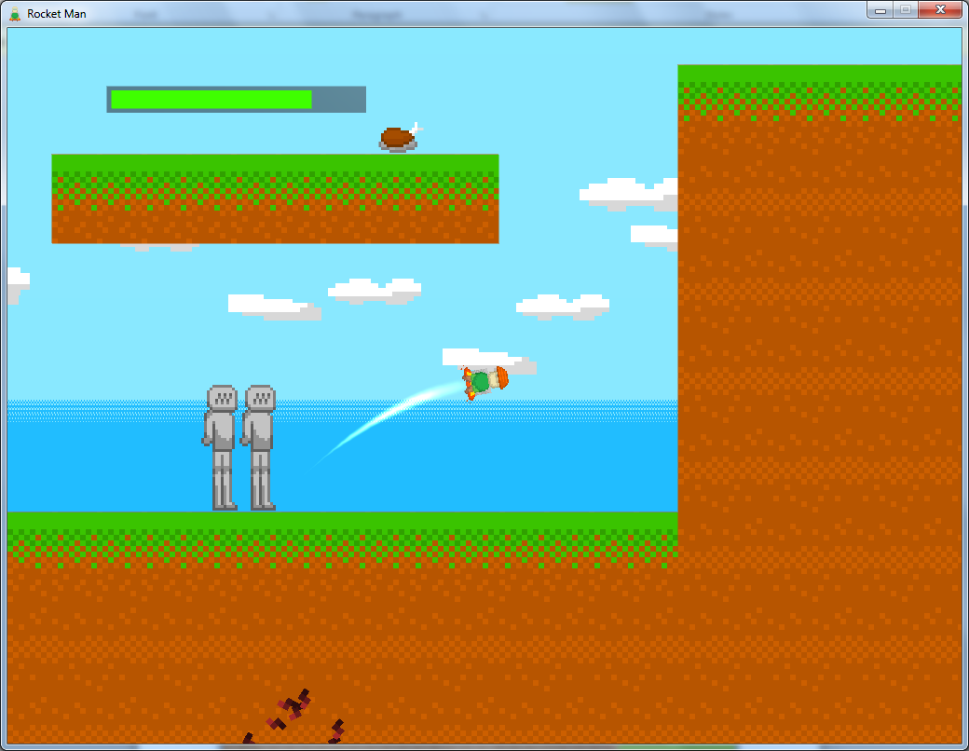
Fig 3: Shortly after being kicked by an enemy knight.

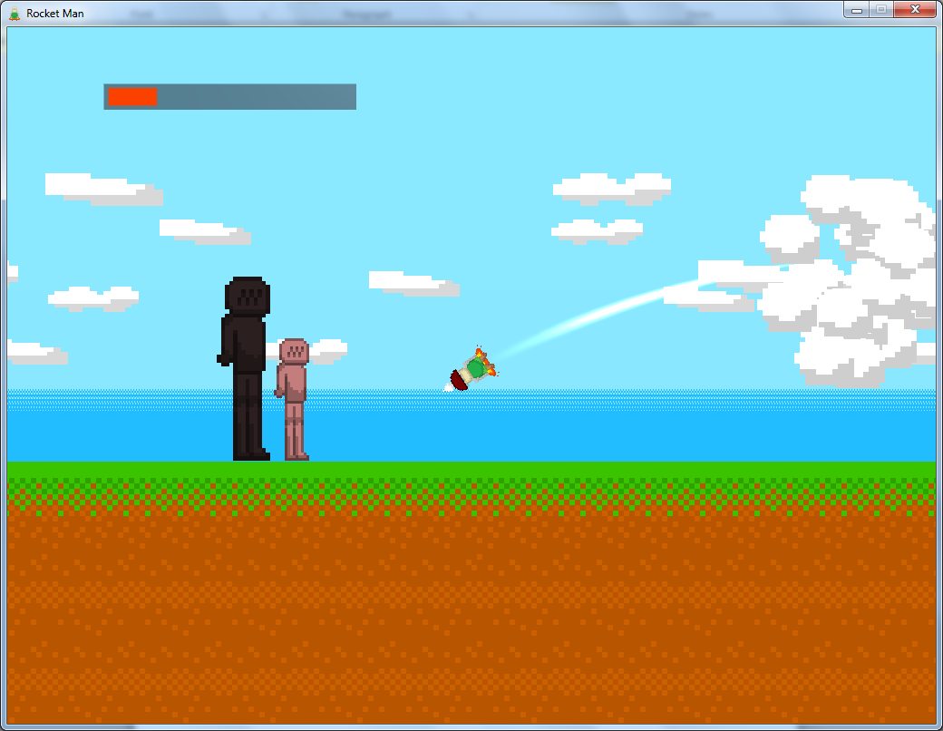
Fig 4: An encounter with a miniboss, the black knight.

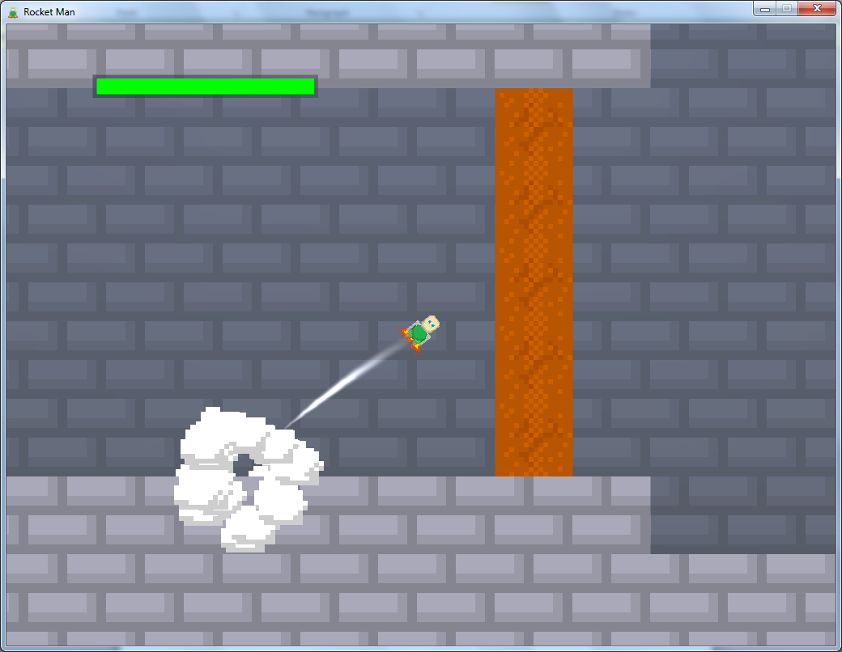
Fig 5: Something appears to be sealed in here...

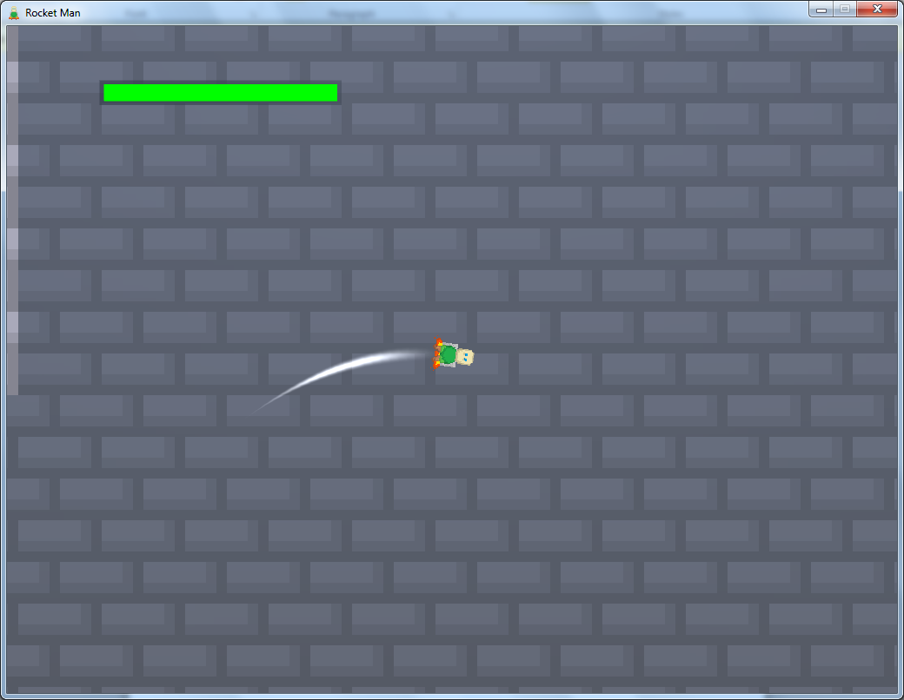
Fig 6: Something big…

